The THGA publishes selected abstracts of Bachelor and Master theses on its website. The goal is to highlight outstanding student work and provide insight into the diversity of academic study, research, and practical relevance. To ensure a consistent format, please use the abstract template provided. Please note the following:
- The abstract must not exceed 5,000 characters (including spaces).
- Illustrations:
  - Photos in JPG format
  - Graphics in PNG or GIF format
  - Please ensure the image is of good quality.
- The abstract must be included as the second last page of your thesis; in addition, you must submit a printed abstract on a special page and a digital version (on the same storage medium that contains the text of your thesis).
Optional: You are welcome to add a brief sentence describing which United Nations Sustainable Development Goal (SDG) the project contributes to.
…………………………………………………………………………………………………………………………………….
Consent Form for the Publication of the Abstract (voluntary)

Name _______________________________________________ Student ID number _________________________
I agree to have the abstract of my Bachelor/Master thesis published on the THGA website.
☐ I consent to the publication of my abstract.
☐ I hereby certify that I am the author of the images/photos and grant THGA the right, without any time or geographical restrictions, to use these images in connection with the publication of the abstract on the THGA website.

Place, Date: Signature: ____________________________

Beendet (finished)

Von/By

Betreuer (supervisor) | ,  ,

Abstract:

Die mögliche Einflussnahme des Primings auf das Konsumentenverhalten bei High-Involvement-Gütern

Possible Influence of priming on consumer behaviour regarding
High-Involvement-Goods

Beendet (finished) 2025-03-06
Example
Von | M. Mustermann
Betreuer (supervisor) |  | Prof. Dr. Alex Mustermann,  WB Elektro-/ Informationstechnik u. Wirtschaftsingenieurwesen  Kim Mustermann, Musterfirma

Im Rahmen der vorliegenden Arbeit wurde die Fragestellung bearbeitet, ob es bei High-Involvement-Gütern möglich ist, einen Konsumenten im Vorfeld durch Priming gezielt in seinem Verhalten zu beein-flussen. Dieses wurde im Rahmen einer experimentellen Datenerhebung erörtert. Es kamen drei aus-gewählte Methoden der apparativen Marktforschung, das Eye-Tracking, die elektrodermale Aktivitäts-messung und das Facial Coding, zum Einsatz. Im Rahmen der experimentellen Untersuchung wurden vorher angesprochene Probanden in drei Gruppen eingeteilt. Während des Experimentes wurden Ver-suchspersonen unterschiedliche TV-Möbel und Heimkinoanlagen präsentiert und währenddessen die relevanten Daten erfasst. Im Anschluss erfolgte die Darstellung und Auswertung der Ergebnisse. Die-se Ergebnisse ermöglichten keine eindeutige Bestätigung oder Falsifizierung der Hypothese, welches beispielsweise auf Fehler in der Methodik zurückzuführen ist, sodass die Methode zukünftig zu verfei-nern ist.

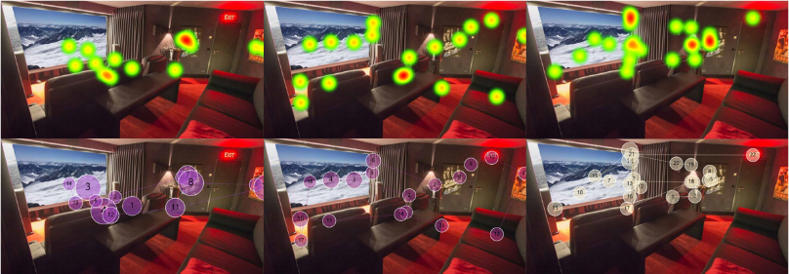
Ausgewählte Heat Maps und Gaze-Plots zu Demonstrationszwecken

Abstract:
Aim of this thesis was to examine whether it is possible to influence a consumer in his behaviour con-cerning high-involvement-goods by priming. In experimental research three selected methods of in-strument-based market research were used. These were Eye-Tracking, measurement of galvanic skin response and facial coding. Before the experiment possible test persons were contacted and divided into three groups. During the experiment different TV-furniture and home cinema-equipment was pre-sented to the test persons. The relevant data was collected simultaneously. Afterwards, the data was presented and analysed. The results did not provide a satisfying basis to confirm or falsify the hypothesis. Methodical mistakes in the conception of the experiment might have led to this result, which makes it necessary to refine the concept in the future.

